How to Register for the Online Course,
A Family Guide to Postsecondary Transition

This is a step-by-step guide for you to take the FREE course by the UConn Center for Excellence in Developmental Disabilities. It is for families of individuals transitioning from school to adult life and for anyone else interested in this process. You have permission to share this page with anyone else you know who wants to take this FREE course!
- Registration. To register for A family guide to post-secondary transition, click on the link below or cut and paste the entire https:// onto the search line of your computer.
https://uconn.geniussis.com/Registration.aspx?AffiliateID=9R21R1.
You will get to a web page with an image that looks like this:
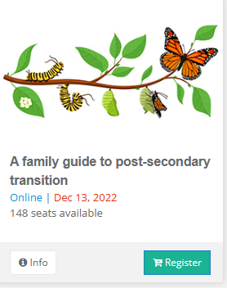

- Click the green Register button in the bottom right corner of the image.
This will add the course to your cart on the upper right corner of the webpage.
- Click on check out to the right of your cart. This will take you to the Registration Page.
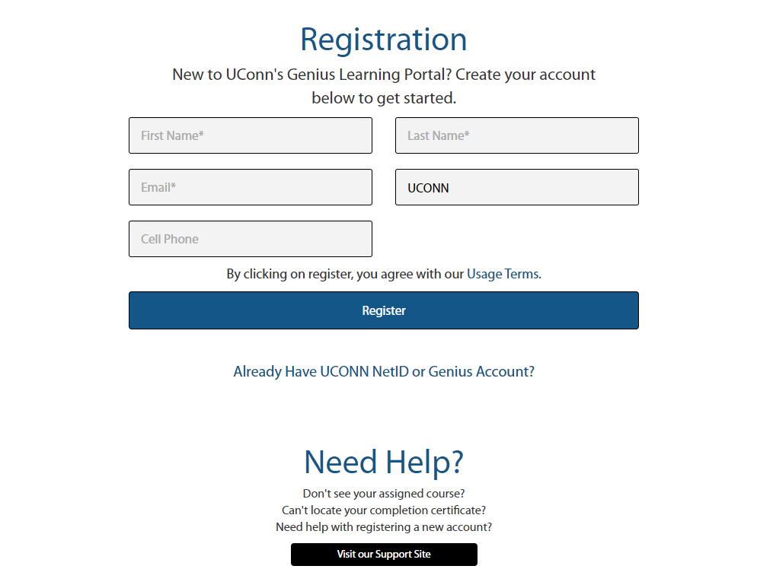

- To create an account needed to take this FREE course, fill in the blanks and click Register.

- You will get taken to the course confirmation page. It has the course logo and the title, A family guide to post-secondary transition. Please read the course description.

Near the bottom of this page, it says Tara Lutz is the Teacher but the course is brought to you by the UConn Center for Excellence in Developmental Disabilities and you should contact Linda Rammler, lrammler@uchc.edu if you have any questions.

- Click on Confirm at the bottom of the page.

- You will now be on a Welcome to the Course Catalog page. There will be a message that looks like this:
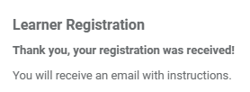
- Click on Go to Dashboard.

- You will now be on the LearnerDashboard page and should have two (2) Messages in your Message Center like this:

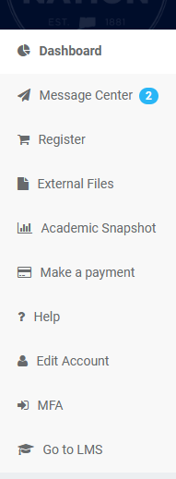

- Click on. . There should be two messages:

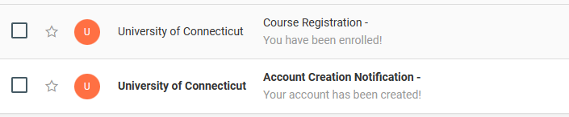

- VERY IMPORTANT: Click on the one that says Account Creation Notification FIRST.
- You will be taken to an email from
which welcomes you to UCONN Noncredit Online Learning!
- Below this you will see something like this:
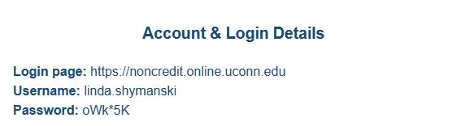
See that your username is the name you used when you signed in.
- NOTE: This password is only temporary but you may want to write this information down or snip and save it in case you get interrupted in the next few minutes.
Read the directions to create a new password before you Click here to login... a

- When you login, you will get to a sign in page. Enter your own name for Genius Username. CREATE A NEW PASSWORD THAT YOU WILL REMEMBER AND WRITE IT DOWN SOMEWHERE!!!!

- 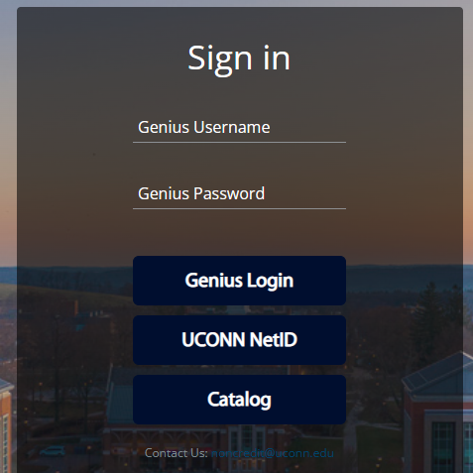

When you click on Genius Login you will be taken to the course. You can leave the course whenever you want to but to get back in you will need to enter your Genius Username and the new Genius Password you created. More instructions for how to proceed are in the body of the course itself.
ENJOY THE COURSE!!!!!

